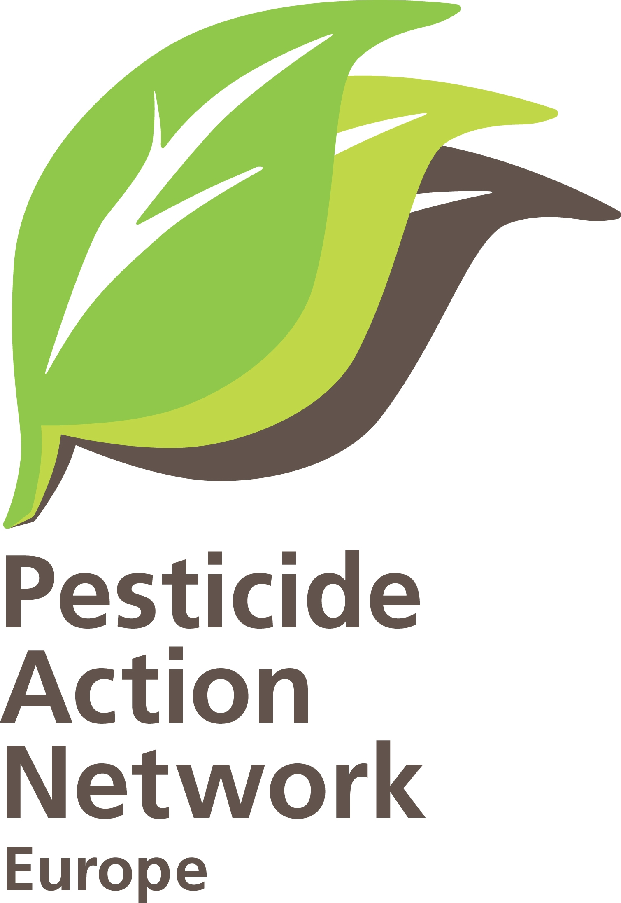
in co-operation
with PAN-Europe

EEB 2nd 2011 Chemicals Working Group meeting
Venue: The World Culture CENTRE
Nørre Allé 7
2200 Copenhagen N

DRAFT AGENDA Final draft

Monday 10th October Evening DINNER

Participants from public interest organizations + speakers are invited for dinner 19:30 at "RizRaz"; Kompagnistræde 20, 1208 Copenhagen K

DAY 2 TUESDAY 11th October

OPEN DAY

Time | Issue | Speaker | Comments  (purpose, expected outcome
8:45-9:00 | Registration and welcome
9:00-9:15 | Welcome | Christian Schaible, EEB | Best is the person to introduce organization when asking questions…so we can start earlier and kick off then  Logistics (breaks, dinner check etc)  Present purpose / objective of this meeting, quick intro to splitting of the 2 days.
 | SESSION I: COCKTAIL EFFECTS
30 min  9:15-9:45 | Mixture effects of endocrine disrupters: Cumulative risk represents a serious gap in current risk assessment requiring major changes to current practice | Ulla Hass  Technical University of Denmark | Make a general intro on cocktail effects with shortcomings + general input on regulatory aspects. Focus on cocktails effects, link to EDC topic.
 | Q & A
15 min  9:45 –  10-00 | Late scientific findings in relation to cocktail effects | Kristian Syberg  Assistant Professor  Dep. Of Env., Social and Spatial Change;  Roskilde University | Scientist to explain the issue, present current state of play, some latest science on the issue, propose recommendations, Point of views
10 min  - 10:10 | Q & A
20 min  10:10 -10:30 | Combined Exposure: Bridging the gap between science, chemical risk assessment and regulation | Olwenn Martin  (Kortenkamp team)  Brunel University | Olwenn is working on the cocktail effects study for the European Commission.  She will give an intro into the subject, present the issue about uncertainty factors (pros and cons of this approach), highlight the gaps.  Need to become more concrete on what should be done at policy level if possible
15 min  -10:45 | Q & A
15 min  10:45-11:00 | Coffee/tea BREAK
20 min  11:00-11:20 | What does the Commission intend to do on considering real life exposure? What are the regulatory options at hand? | Björn Hansen  Deputy Head of Unit, DG Environment, European Commission | General overview on different regulatory options (general) and EU wide approach before getting to MS level (DK)
10 min  -11:30 | Q & A
30 minutes  11:30-12:00 | Regulatory response on how to address cocktail effects – The Danish Presidency / EPA point of view | Henrik Søren Larsen  Danish EPA | DK Presidency / EPA to present what - in their view - is the critical issue, what they plan to do at EU level + how.  (We need to find out if they already have made up their mind on this, dig into their approach and have exchange on pro and cons)
45 min? | Discussion round | ALL PARTICPANTS | Allow all participants to interact on the topic. Hope to have a clear understanding of the problem, pros and cons of regulatory responses and how to move forward that issue
12:45-14:00 | Lunch BREAK
 | SESSION II: EDC SESSION
10 min  14:00-14:10 | The problem with EDCs, political demands in DK –the citizens perspective | Claus Jørgensen  Danish Consumer Council | General Intro to the topic / background in DK, citizen’s perspective.
5 min-14:15 | Q & A
15 min  14:15 – 14:30 | Developmental toxicity of pesticides - implications for risk assessment | Helle Raun Andersen  Associate professor, Environmental Medicine; University of Southern Denmark | Presentation on scientific findings on why EDC need special attention (example of risk assessments on pesticides)
10min  - 14:40 | Q & A
10min  14:40-14:50 | Coffee / tea BREAK
10 min  14:50-15:00 | NGO views on requirements for the proper regulation of EDCs | Gwynne Lyons  ChemTrust | NGO to quickly present our joint position paper 2011
20 min  15:00-15:20 | Commission response to NGO views on requirements for the proper regulation of EDCs (NGO Position paper 2011) | Björn Hansen  Deputy Head of Unit, DG Environment, European Commission | COM to respond to the recommendation points mentioned in the April 2011 joint PP.  (+ General overview on latest news in relation to EU EDC strategy, REACH 2012 review, EDC criteria, other EU policy before getting to MS level (DK))
10 min  -15:30 | Q& A
20 min  15:30-15:50 | Acting on reducing exposure from EDCs:  Danish proposal for EDC criteria | Pia Juul Nielsen  Danish EPA | Stay at rather general level on what fronts the DK Presidency will work and intro to/explain DK EDC criteria
10 min  - 16:00 | Q& A
20 min  16:00-16:20 | NGO critique on proposed EDC criteria: what are the crucial points? | Gwynne Lyons  ChemTrust | Gwynne will make a general critique to the EDC criteria proposals (ex. DK) but also in relation to highlight of 3 key issues. Present the preliminary NGO position on these aspects.  (tutorial on NGO position on EDC criteria)
20 minutes  -16:40 | Q&A, DISCUSSION ROUND | ALL PARTICIPANTS
10 min | Coffee / tea BREAK
20 min  16:50 -17:10 | The use of “Science”  (example of Glyphosate) | Claire Robinsen  Earth OpenSource | Scientist to talk about GLP, testing design, independence of science/regulators to do RA decisions etc  As example chemical propose Glyphosate
10 min | Q & A
17:20-17:30 | WRAP UP / CONCLUSIONS | Hans Muilerman  PAN-EU | Might be useful to wrap up and summarize with key conclusions.
<  17:30 | END FIRST DAY

Participants from public interest organizations + speakers are invited for dinner at 19.00 at "Økocafeen 32"; Nørrebrogade 32A, 2200 Copenhagen N

